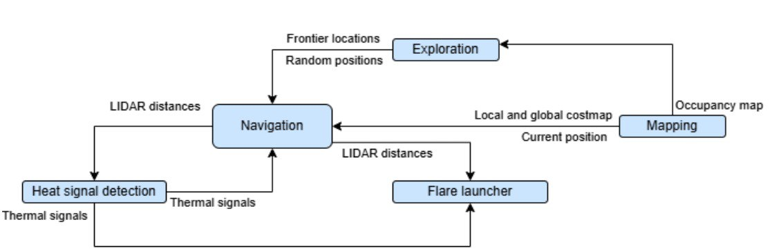

**Interface Control Flowchart**

The flowchart illustrates the software architecture and data flow in the autonomous Turtlebot system designed for IR-based search and targeting. The core of the system is the Navigation module, which receives frontier locations or random positions from the Exploration module to guide the robot through the environment. The Mapping module continuously updates the local and global costmap and provides the current position based on the occupancy map, feeding this information to the Navigation module for real-time decision-making. Simultaneously, LiDAR distances are used by both the Navigation module and the Heat Signal Detection unit to localize and identify thermal targets. Upon detecting valid thermal signals, the Heat Signal Detection module relays data to the Flare Launcher, which uses both thermal and LiDAR inputs to determine when and where to launch a flare. This integrated loop allows for autonomous mapping, exploration, and accurate response to heat-based targets within a complex maze environment.